# VISVESVARAYA TECHNOLOGICAL UNIVERSITY

## BELAGAVI – 590018, Karnataka INTERNSHIP REPORT

#### ON

“Jyoti – Assistant for the Blind”

***Submitted in partial fulfilment for the award of degree(18CSI85)***

## BACHELOR OF ENGINEERING IN

## AIML

***Submitted by:***

#### Nidhi Mahagaonkar

#### 1BG20AI054

LOGO Ex:

Conducted at

**COMPSOFT TECHNOLOGIES**



# B.N.M. Institute of Technology

**Department of Artificial Intelligence and Machine Learning**

**Approved by AICTE, Affiliated to VTU, Accredited as grade A Institution by NAAC.**

**All UG branches – CSE, ECE, EEE, ISE & Mech.E accredited by NBA for academic years 2018-19 to 2020-21 & valid upto 30.06.2021**

Post box no. 7087, 27th cross, 12th Main, Banashankari 2nd Stage, Bengaluru- 560070, INDIA

Ph: 91-80- 26711780/81/82   Email: [principal@bnmit.in](mailto:principal@bnmit.in), www. bnmit.org

# B.N.M. Institute of Technology

**Department of Artificial Intelligence and Machine Learning**

**Approved by AICTE, Affiliated to VTU, Accredited as grade A Institution by NAAC.**

**All UG branches – CSE, ECE, EEE, ISE & Mech.E accredited by NBA for academic years 2018-19 to 2020-21 & valid upto 30.06.2021**

Post box no. 7087, 27th cross, 12th Main, Banashankari 2nd Stage, Bengaluru- 560070, INDIA

Ph: 91-80- 26711780/81/82   Email: [principal@bnmit.in](mailto:principal@bnmit.in), www. bnmit.org



**CERTIFICATE**

This is to certify that the Internship titled **“Jyoti-Assistant for the Blind”** carried out by **Ms. Nidhi Mahagaonkar,** a bonafide student of BNM Institute of Technology, in partial fulfillment for the award of **Bachelor of Engineering**, in **AIML** under Visvesvaraya Technological University, Belagavi during the year 2023-2023. It is certified that all corrections/suggestions indicated have been incorporated in the report.

The project report has been approved as it satisfies the academic requirements in respect of Internship prescribed for the course Internship / Professional Practice (18CSI85)

#### Signature of Guide Signature of HOD Signature of Principal

**External Viva:**

Name of the Examiner Signature with Date

1)

2)

# D E C L A R A T I O N

I, **Nidhi Mahagaonkar**, final year student of Branch, College Name - 560 082, declare that the Internship has been successfully completed, in **COMPSOFT TECHNOLOGIES**. This report is submitted in partial fulfillment of the requirements for award of Bachelor Degree in Branch name, during the academic year 2023-2023.

Date : 12/10/23 :

Place : Bangalore

USN : 1BG20AI054

NAME : Nidhi

**OFFER LETTER**



# A C K N O W L E D G E M E N T

This Internship is a result of accumulated guidance, direction and support of several important persons. We take this opportunity to express our gratitude to all who have helped us to complete the Internship.

We express our sincere thanks to our Principal Dr Krishnamurthy G.N, for providing us adequate facilities to undertake this Internship.

We would like to thank our Head of Dept Dr Sheba Selvam, for providing us an opportunity to carry out Internship and for his valuable guidance and support. We would like to thank our course teacher Ms Abhilasha P Kumar Software Services for guiding us during the period of internship.

We express our deep and profound gratitude to our guide, Nagarathna C.R, Assistant/Associate Prof, for her keen interest and encouragement at every step in completing the Internship.

We would like to thank all the faculty members of our department for the support extended during the course of Internship.

We would like to thank the non-teaching members of our dept, forhelping us during the Internship.

Last but not the least, we would like to thank our parents and friends without whose constant help, the completion of Internship would have not been possible.

**Nidhi Mahagaonkar**

**1BG20AI054**

# ABSTRACT

In an era driven by technological innovations, the story of Jyoti, a remarkable blind assistant, stands as a testament to the power of determination and human potential. Jyoti, despite her visual impairment, defies societal expectations and limitations by proving that disability is not synonymous with incapability.

Jyoti's journey towards becoming a blind assistant is one of resilience and adaptability. Through advanced technology and specialized training, she has harnessed the potential of artificial intelligence and voice-controlled devices to provide support and assistance to individuals with disabilities. Her capabilities extend to various domains, such as reading text aloud, answering questions, managing daily tasks, and aiding navigation, thereby enhancing the quality of life for those who rely on her services.

# Table of Contents

|  |  |  |
| --- | --- | --- |
| **Sl no** | **Description** | **Page no** |
| 1 | Company Profile |  |
| 2 | About the Company |  |
| [3](https://1.bp.blogspot.com/-dODuK8N5h1Q/Wlnyb3V9HFI/AAAAAAAACL4/WxQtCJ1pM5wccDABg4wIrTBUB0vlikXQQCLcBGAs/s1600/poly1.jpg) | Introduction |  |
| [4](https://1.bp.blogspot.com/-dODuK8N5h1Q/Wlnyb3V9HFI/AAAAAAAACL4/WxQtCJ1pM5wccDABg4wIrTBUB0vlikXQQCLcBGAs/s1600/poly1.jpg) | System Analysis |  |
| [5](https://1.bp.blogspot.com/-dODuK8N5h1Q/Wlnyb3V9HFI/AAAAAAAACL4/WxQtCJ1pM5wccDABg4wIrTBUB0vlikXQQCLcBGAs/s1600/poly1.jpg) | Requirement Analysis |  |
| 6 | Design [Analysis](https://4.bp.blogspot.com/-IOOxgPaXMVc/Wlj3LWvcnjI/AAAAAAAACKE/UeTFYvAxDmUDel5UBjdifeWaApB3-dXVgCLcBGAs/s1600/img1.jpg) |  |
| 7 | [Implementation](https://4.bp.blogspot.com/-IOOxgPaXMVc/Wlj3LWvcnjI/AAAAAAAACKE/UeTFYvAxDmUDel5UBjdifeWaApB3-dXVgCLcBGAs/s1600/img1.jpg) |  |
| 8 | Snapshots |  |
| 9 | Conclusion |  |
| 10 | References |  |

[**CHAPTER**](https://1.bp.blogspot.com/-dODuK8N5h1Q/Wlnyb3V9HFI/AAAAAAAACL4/WxQtCJ1pM5wccDABg4wIrTBUB0vlikXQQCLcBGAs/s1600/poly1.jpg) **1** **COMPANY PROFILE**

# COMPANY PROFILE

## A Brief History of Company

Company, was incorporated with a goal ”To provide high quality and optimal Technological Solutions to business requirements of our clients”. Every business is a different and has a unique business model and so are the technological requirements. They understand this and hence the solutions provided to these requirements are different as well. They focus on clients requirements and provide them with tailor made technological solutions. They also understand that Reach of their Product to its targeted market or the automation of the existing process into e-client and simple process are the key features that our clients desire from Technological Solution they are looking for and these are the features that we focus on while designing the solutions for their clients.

Company is a Technology Organization providing solutions for all web design and development, MYSQL, PYTHON Programming, HTML, CSS, ASP.NET and LINQ. Meeting the ever increasing automation requirements, Sarvamoola Software Services. specialize in ERP, Connectivity, SEO Services, Conference Management, effective web promotion and tailor-made software products, designing solutions best suiting clients requirements.

we strive to be the front runner in creativity and innovation in software development through their well-researched expertise and establish it as an out of the box software development company in Bangalore, India. As a software development company, they translate this software development expertise into value for their customers through their professional solutions.

They understand that the best desired output can be achieved only by understanding the clients demand better. At our Company we work with them clients and help them to defiine their exact solution requirement. Sometimes even they wonder that they have completely redefined their solution or new application requirement during the brainstorming session, and here they position themselves as an IT solutions consulting group comprising of high caliber consultants.

They believe that Technology when used properly can help any business to scale and achieve new heights of success. It helps Improve its efficiency, profitability, reliability; to put it in one sentence ” Technology helps you to Delight your Customers” and that is what we want to achieve.

# [CHAPTER](https://1.bp.blogspot.com/-dODuK8N5h1Q/Wlnyb3V9HFI/AAAAAAAACL4/WxQtCJ1pM5wccDABg4wIrTBUB0vlikXQQCLcBGAs/s1600/poly1.jpg) 2 ABOUT THE COMPANY

1. **ABOUT THE COMPANY**

We are a Technology Organization providing solutions for all web design and development, Researching and Publishing Papers to ensure the quality of most used ML Models, MYSQL, PYTHON Programming, HTML, CSS, ASP.NET and LINQ. Meeting the ever increasing automation requirements, Compsoft Technologies specialize in ERP, Connectivity, SEO Services, Conference Management, effective web promotion and tailor-made software products, designing solutions best suiting clients requirements. The organization where they have a right mix of professionals as a stakeholders to help us serve our clients with best of our capability and with at par industry standards. They have young, enthusiastic, passionate and creative Professionals to develop technological innovations in the field of Mobile technologies, Web applications as well as Business and Enterprise solution. Motto of our organization is to “Collaborate with our clients to provide them with best Technological solution hence creating Good Present and Better Future for our client which will bring a cascading a positive effect in their business shape as well”. Providing a Complete suite of technical solutions is not just our tag line, it is Our Vision for Our Clients and for Us, We strive hard to achieve it.

## Services provided by Compsoft Technologies.

* Core Java and Advanced Java
* Research and Development/Improvise of ML Models
* Web services and development
* Dot Net Framework
* Python
* Selenium Testing
* Conference / Event Management Service
* Academic Project Guidance
* On The Job Training
* Software Training

# [CHAPTER](https://1.bp.blogspot.com/-dODuK8N5h1Q/Wlnyb3V9HFI/AAAAAAAACL4/WxQtCJ1pM5wccDABg4wIrTBUB0vlikXQQCLcBGAs/s1600/poly1.jpg) 3 INTRODUCTION

1. **INTRODUCTION**

## Introduction to ML

Machine learning is a dynamic field within the realm of artificial intelligence that revolutionizes how computers operate and make decisions. It is a process by which computer systems are designed to autonomously improve their performance over time, without relying on explicit programming. Instead, they analyze and learn from vast sets of data, recognizing intricate patterns, relationships, and trends. The core concept behind machine learning is that it allows computers to adapt and evolve, optimizing their own performance based on the information they process. This adaptability makes machine learning systems particularly valuable in addressing complex problems and tasks, ranging from natural language processing and image recognition to financial modeling and autonomous decision-making.

## Problem Statement

Individuals with visual impairments face significant challenges in accessing information, managing daily tasks, and achieving independence. Existing assistive technologies for the blind often lack versatility, user-friendliness, and affordability, making it a pressing concern to develop a comprehensive and accessible assistant like Jyoti. The problem at hand is to design and implement a user-centric, cost-effective, and technologically advanced assistant, addressing the unique needs of the visually impaired, to enhance their quality of life and promote their autonomy. The primary problem lies in the inadequacy of current solutions, which tend to be fragmented and often costly, impeding their widespread adoption and effectiveness. These limitations result in reduced autonomy and quality of life for the visually impaired, as they struggle with tasks like reading printed materials, navigating unfamiliar environments, accessing digital content, or even managing everyday tasks independently. Furthermore, a critical aspect of this problem pertains to the accessibility and affordability of assistive technologies for the blind. Many individuals, particularly in developing regions, have limited access to the latest technological advancements, which places them at a significant disadvantage in terms of education, employment opportunities, and overall quality of life.

# [CHAPTER](https://1.bp.blogspot.com/-dODuK8N5h1Q/Wlnyb3V9HFI/AAAAAAAACL4/WxQtCJ1pM5wccDABg4wIrTBUB0vlikXQQCLcBGAs/s1600/poly1.jpg) 4 SYSTEM ANALYSIS

**4. SYSTEM ANALYSIS**

## Existing System

The existing system designed to aid the visually impaired, "Jyoti" Voice Assistant, is a groundbreaking solution that combines advanced technology and custom hardware to cater to the specific needs of individuals with visual impairments. Unlike conventional assistive technologies, "Jyoti" stands out by offering a comprehensive suite of features that encompass object recognition, text-to-speech capabilities, and even form reading. It leverages a unique hardware setup, featuring wearable headphones connected to a Logitech webcam interfaced with a Raspberry Pi. This innovative approach not only enhances the user's understanding of their surroundings but also empowers them with the ability to interact with their environment through speech commands. "Jyoti" is a testament to the possibilities of technology when harnessed for inclusivity and accessibility, promising to significantly improve the quality of life for the visually impaired.

1. **Proposed System**

The "Jyoti" Voice Assistant represents a cutting-edge proposal aimed at addressing the unique challenges faced by the visually impaired. This innovative system envisions a holistic solution that combines state-of-the-art technology with custom hardware. By integrating wearable headphones with a Logitech webcam and Raspberry Pi, "Jyoti" empowers visually impaired users with a range of indispensable features. These features include real-time descriptions of their surroundings, guidance on road conditions, location awareness, object recognition, and the ability to locate specific items. The system also excels in text recognition and reading, even summarizing articles from newspapers. Moreover, "Jyoti" fills a critical need by assisting with form reading, mobile interactions, and basic chatbot functions. This proposed system promises to revolutionize the lives of the visually impaired, fostering independence and accessibility on a new level through innovative technology and tailored assistance.

## Objective of the System

## The overarching objective of the "Jyoti" Voice Assistant system is to revolutionize the daily experiences and living conditions of the visually impaired by providing an all-encompassing, technologically advanced, and highly personalized solution. At its core, "Jyoti" strives to empower individuals with visual impairments with an unprecedented level of independence, accessibility, and information. By combining innovative hardware, including wearable headphones interfaced with a Logitech webcam and Raspberry Pi, with cutting-edge software capabilities, the system aims to offer a wide range of essential features.

Foremost among these objectives is the provision of real-time, context-aware descriptions of the user's immediate surroundings, assisting in tasks as fundamental as orientation and mobility. "Jyoti" seeks to bridge the informational gap by delivering insights into road conditions, providing location awareness, and recognizing common places such as classrooms, kitchens, and bedrooms. Moreover, it aims to enhance the user's situational awareness by detecting and reporting the number of people, objects, and entities within the webcam's field of view.

Additionally, the system is designed to respond to commands for locating specific objects or entities, leveraging advanced entity recognition. It can read text from images and articles, thereby granting access to printed content and supporting literacy. Furthermore, "Jyoti" extends its utility to tasks such as form reading, an essential function with significant implications for activities like banking and administrative paperwork. The system doesn't stop at environmental interactions; it extends its reach to mobile device interactions, reading out notifications, messages, emails, and calendars, and even responding to user inquiries. Additionally, as a chatbot, "Jyoti" answers basic questions, including queries about time, lighting conditions, and a range of other "wh" questions. In sum, the multifaceted objective of the "Jyoti" Voice Assistant is to elevate the quality of life for the visually impaired, making available an unprecedented suite of features that promote independence, accessibility, and inclusivity. This visionary system aspires to leverage the power of technology and custom-designed hardware to create an inclusive environment that empowers visually impaired individuals to live more autonomously and comfortably, irrespective of their surroundings or challenges.

# [CHAPTER](https://1.bp.blogspot.com/-dODuK8N5h1Q/Wlnyb3V9HFI/AAAAAAAACL4/WxQtCJ1pM5wccDABg4wIrTBUB0vlikXQQCLcBGAs/s1600/poly1.jpg) 5 REQUIREMENT ANALYSIS

**5. REQUIREMENT ANALYSIS**

## Hardware Requirement Specification

For performing the examples discussed in this tutorial, you will need a Pentium 200-MHz computer with a minimum of 64 MB of RAM (128 MB of RAM recommended).

− ● Linux 7.1 or Windows xp/7/8/10 or any operating system

● Any IDE(VS Code recommended)

## Software Requirement Specification

1. SpeechRecognizer, Google API for speech to text conversion

2. Python Text to Speech https://pypi.org/project/pyttsx3/

3. Object Recogniiton using *COCO Dataset*

4. Google Cloud Vision API

5. Dialogflow

# [CHAPTER](https://1.bp.blogspot.com/-dODuK8N5h1Q/Wlnyb3V9HFI/AAAAAAAACL4/WxQtCJ1pM5wccDABg4wIrTBUB0vlikXQQCLcBGAs/s1600/poly1.jpg) 6 DESIGN ANALYSIS

1. **DESIGN & ANALYSIS**

The development of the "Jyoti" Voice Assistant entails a meticulous design and analysis phase, critical to its mission of enhancing the lives of the visually impaired. In the design phase, the project team has meticulously defined the scope, objectives, and functionalities of the system. The planning process has created a comprehensive project plan that outlines the tasks, timelines, and resource allocation required for its successful implementation. Additionally, a detailed communication plan has been established to ensure efficient information flow among stakeholders, while a robust quality assurance and testing framework will guarantee that "Jyoti" meets the highest standards of performance and accessibility.

In the analysis phase, the "Jyoti" project underwent a thorough requirement analysis, encompassing the needs of the visually impaired community and the technical specifications necessary to fulfill these needs. A feasibility study examined the economic, technical, and operational viability of the project, ensuring its real-world applicability. Risk analysis identified potential challenges and developed strategies to mitigate them, while cost estimation laid out the financial resources required for project execution. Regulatory considerations, ethical guidelines, and compliance requirements have been addressed, ensuring that "Jyoti" adheres to the necessary standards. Documentation processes have been initiated to create comprehensive user manuals and maintenance guidelines. Throughout the analysis phase, stakeholder reviews and approvals have been conducted to ensure that "Jyoti" aligns with its objectives, functions effectively, and effectively addresses the needs of the visually impaired community.

# [CHAPTE](https://1.bp.blogspot.com/-dODuK8N5h1Q/Wlnyb3V9HFI/AAAAAAAACL4/WxQtCJ1pM5wccDABg4wIrTBUB0vlikXQQCLcBGAs/s1600/poly1.jpg)R 7 IMPLEMENTATION

1. **IMPLEMENTATION**

Implementation is the stage where the theoretical design is turned into a working system. The most crucial stage in achieving a new successful system and in giving confidence on the new system for the users that it will work efficiently and effectively.

The system can be implemented only after thorough testing is done and if it is found to work according to the specification. It involves careful planning, investigation of the current system and it constraints on implementation, design of methods to achieve the change over and an evaluation of change over methods a part from planning.

Two major tasks of preparing the implementation are education and training of the users and testing of the system. The more complex the system being implemented, the more involved will be the system analysis and design effort required just for implementation.

The implementation phase comprises of several activities. The required hardware and software acquisition is carried out. The system may require some software to be developed. For this, programs are written and tested. The user then changes over to his new fully tested system and the old system is discontinued.

## TESTING

The testing phase is an important part of software development. It is the Information zed system will help in automate process of finding errors and missing operations and also a complete verification to determine whether the objectives are met and the user requirements are satisfied. Software testing is carried out in three steps:

1. The first includes unit testing, where in each module is tested to provide its correctness, validity and also determine any missing operations and to verify whether the objectives have been met. Errors are noted down and corrected immediately.
2. Unit testing is the important and major part of the project. So errors are rectified easily in particular module and program clarity is increased. In this project entire system is divided into several modules and is developed individually. So unit testing is conducted to individual modules.
3. The second step includes Integration testing. It need not be the case, the software whose modules when run individually and showing perfect results, will also show perfect results when run as a whole.

# [CHAPTE](https://1.bp.blogspot.com/-dODuK8N5h1Q/Wlnyb3V9HFI/AAAAAAAACL4/WxQtCJ1pM5wccDABg4wIrTBUB0vlikXQQCLcBGAs/s1600/poly1.jpg)R 8 SNAPSHOTS

* 1. **SNAPSHOTS**

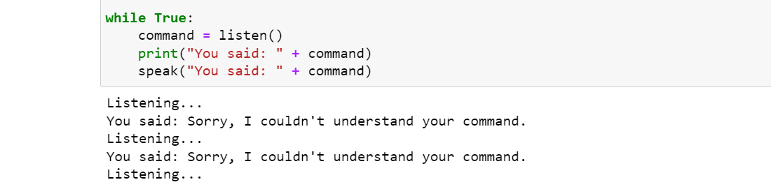

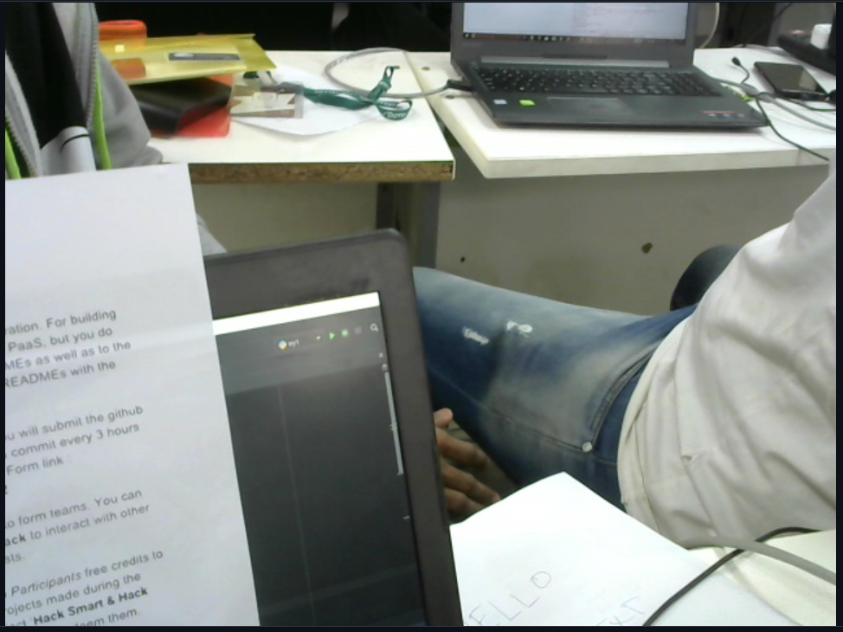

# [CHAPTE](https://1.bp.blogspot.com/-dODuK8N5h1Q/Wlnyb3V9HFI/AAAAAAAACL4/WxQtCJ1pM5wccDABg4wIrTBUB0vlikXQQCLcBGAs/s1600/poly1.jpg)R 9 CONCLUTION

* 1. **CONCLUTION**

The package was designed in such a way that future modifications can be done easily. The following conclusions can be deduced from the development of the project:

* Automation of the entire system improves the efficiency
* It provides a friendly graphical user interface which proves to be better when compared to the existing system.
* It gives appropriate access to the authorized users depending on their permissions.
* It effectively overcomes the delay in communications.
* Updating of information becomes so easier
* System security, data security and reliability are the striking features.
* The System has adequate scope for modification in future if it is necessary.

# REFERENCE

[1] Ashwani Kumar, Ankush Chourasia “Blind Navigation System Using Artificial Intelligence” Dept. of Electronics and Communication Engineering, IMS Engineering College, INDIA

[2] Ms. Rupali, D Dharmale, Dr. P.V. Ingole, "Text Detection and Recognition with Speech Output for Visually Challenged Person",vol. 5, Issue 1, January 2016

[3] Nagaraja, L., et al. "Vision based text recognition using raspberry PI." National Conference on Power Systems, Industrial Automation (NCPSIA 2015).

[4] Ezaki, Nobuo, et al. "Improved text-detection methods for a camerabased text reading system for visually impaired persons." Eighth International Conference on Document Analysis and Recognition (ICDAR’05). IEEE, 2005.

[5] Ms. Kavya. S ,Ms. Swathi Scholar “Assistance System for Visually Impaired using

[6] Padma Shneha1, Prathyusha Reddy2, V.M.Megala3 “Artificial Intelligence For Vision Impaired People “International Journal Of Latest Trends In Engineering And Technology Special Issue April2018, Pp. 031-036 E-ISSN:2278-621X

[7] Ani R1, Effy Maria2, J Jameema Joyce3, Sakkaravarthy V4, Dr.M.A.Raja “Smart Specs: Voice Assisted Text Reading System For Visually Impaired Persons Using TTS Method” IEEE International Conference On Innovations In Green Energy And Healthcare Technologies(ICIGEHT’17)

[8] Xiaofang Jin, Ying Xu “Research on Facial Expression Recognition Based on Deep Learning” Authorized Licensed Use Limited To: University of Canberra. Downloaded On June 07,2020 at 15:35:56 UTC From IEEE Xplore.

[9] Ashwani Kumar, S Sai Satyanarayana Reddy, Vivek Kulkarni “An Object Detection Technique for Blind People in Real-Time Using Deep Neural Network” 2019

[10] G. Littlewort, M. Bartlett, I. Fasel, J. Susskind, and J. Movellan. Dynamics of facial expression extracted automatically from video. Image and Vision Computing, 24(6), 2006.

[11] P. Ekman, W. Friesen, Facial Action Coding System: A Technique for the Measurement of Facial Movement, Consulting Psychologists Press, 1978 International Journal of Engineering Research & Technology (IJERT) ISSN: 2278-0181 Published by, www.ijert.org NCCDS - 2021 Conference Proceedings Volume 9, Issue 12 Special Issue - 2021 271